BUILD Triggers

POLL SCM –As soon as a build takes place in repository , our job should get executed.

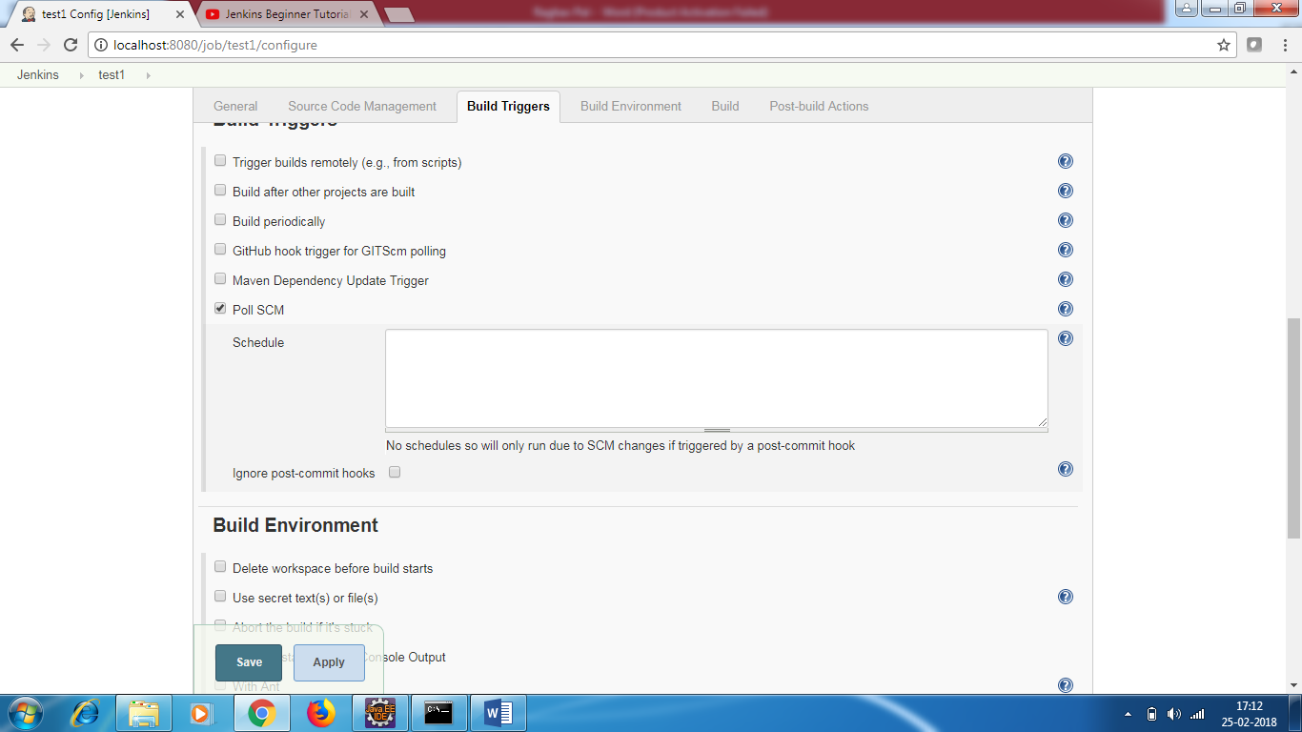

**Build periodically –**

We can assign some expression and based on that our job will run at some particular interval.

Minute Hour DOM (day of month) Month DOW(day of week)

* * * * * - every min

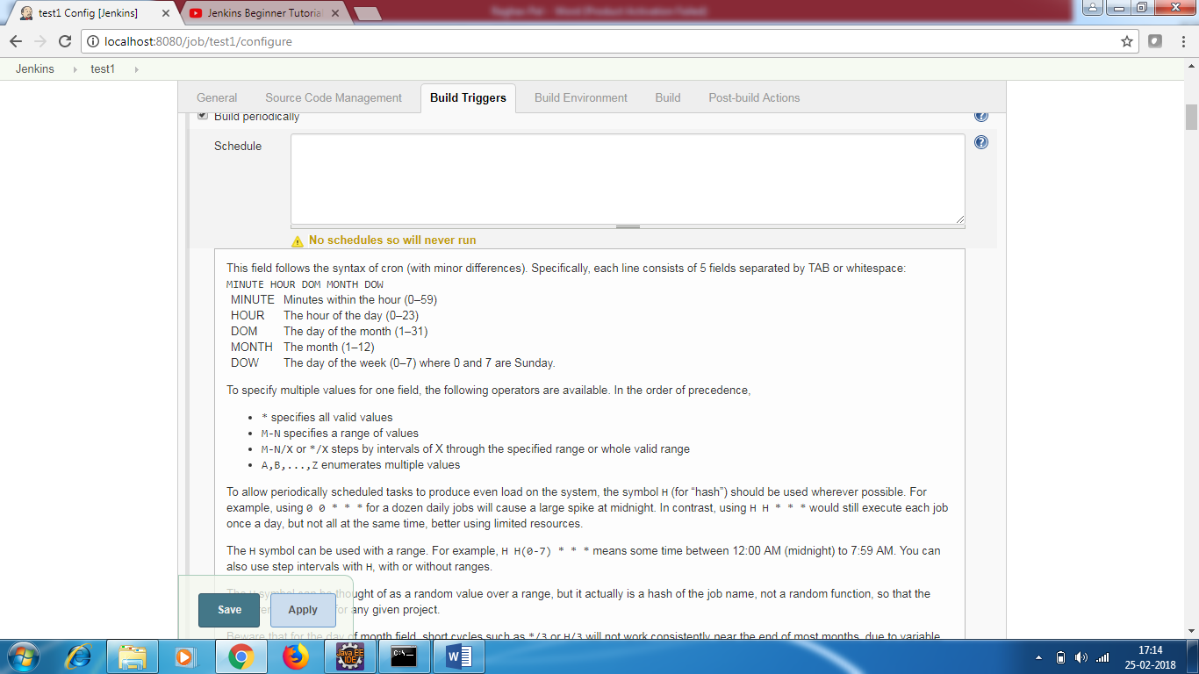

**Build**

Execute windows batch command

Date

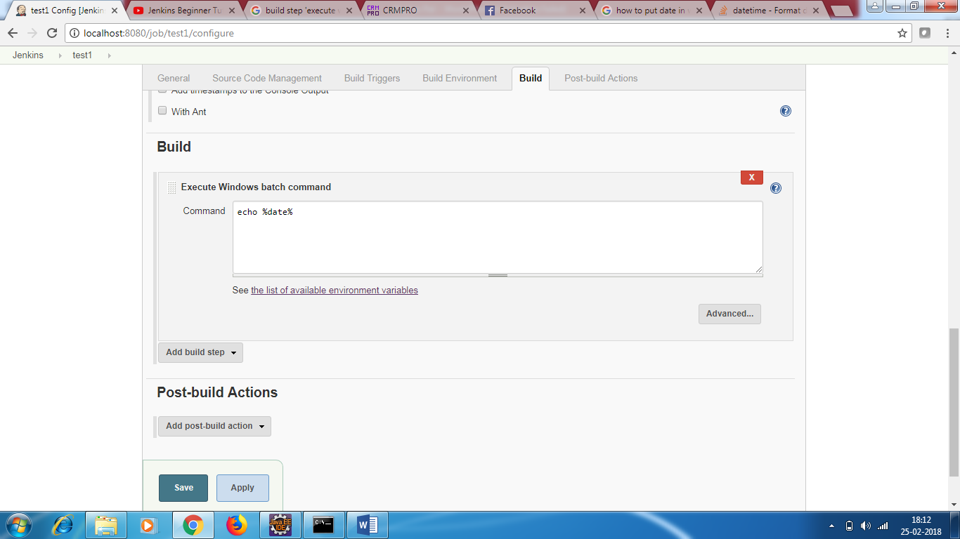

Save and run

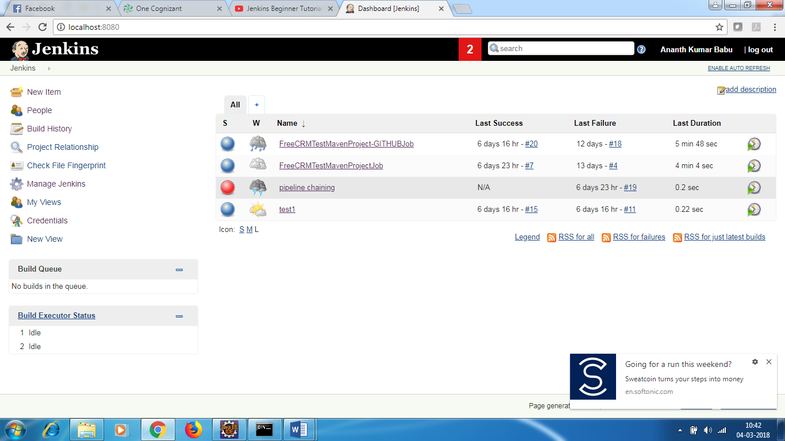

S column – denotes last run

W – weather denotes status of last 5 runs.

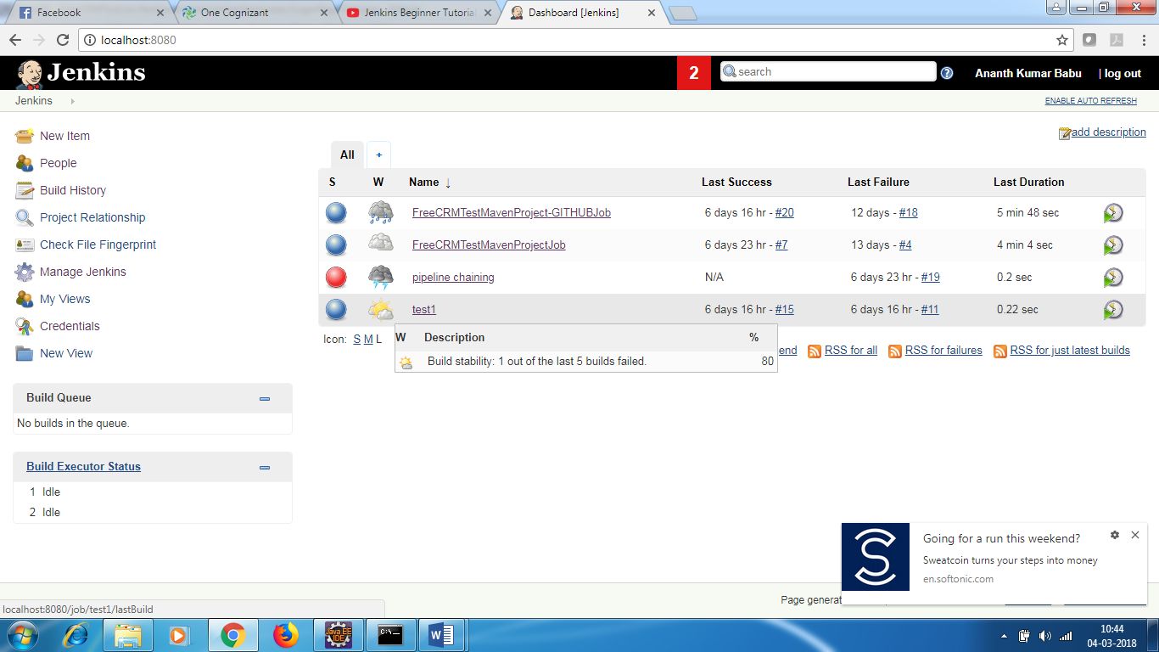

How can u trigger the build remotely?

How to trigger build remotely doesn’t appear

Enable the security setting, go to <http://yourhost/jenkins/configureSecurity> and select enable security, then choose Delegate to servlet container for security realm and Legacy mode for authorization strategy. Or, you may click on the Manage Jenkins link on the left side of the main Jenkins dashboard page to get to the configuration page, then click Configure Global Security.

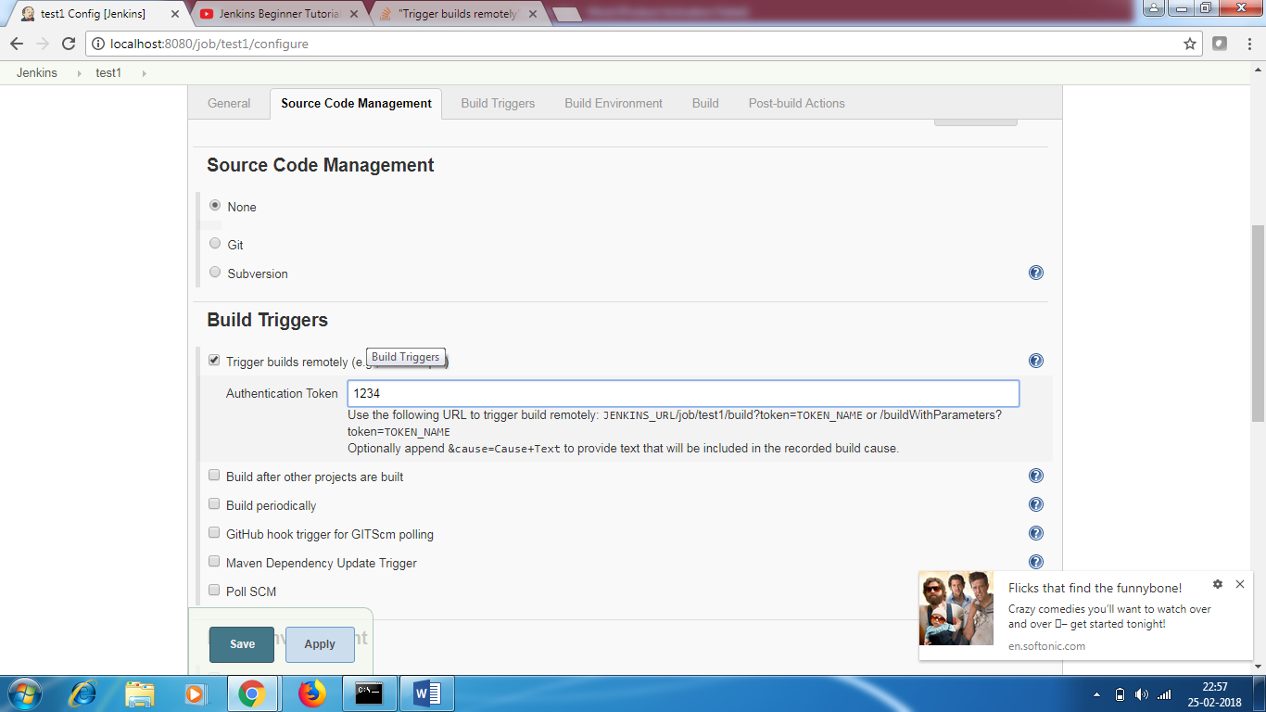

You can copy the url <http://localhost:8080/job/test1/build?token=1234> and run it on other browser and when you refresh the job will execute

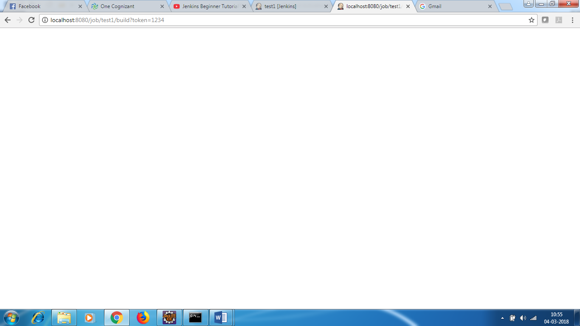

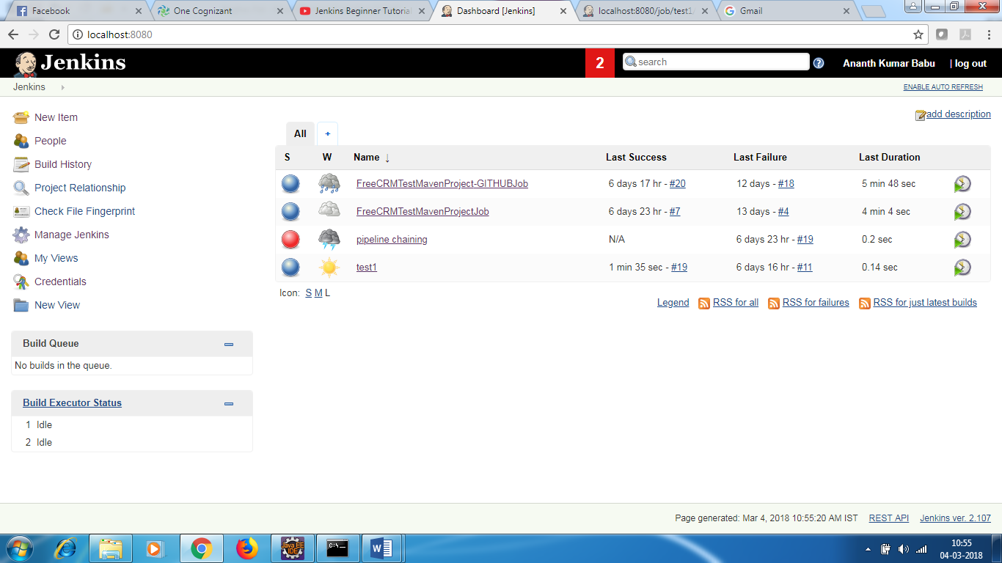

When you trigger , sometimes it will say build queue

You can see build 19 is already executed.

How to chain job execution

Create simple project test2 and test 3. Both has windows command cmd

Go to test2 configure

* In build triggers - select build after other projects are built

Projects to watch – test1

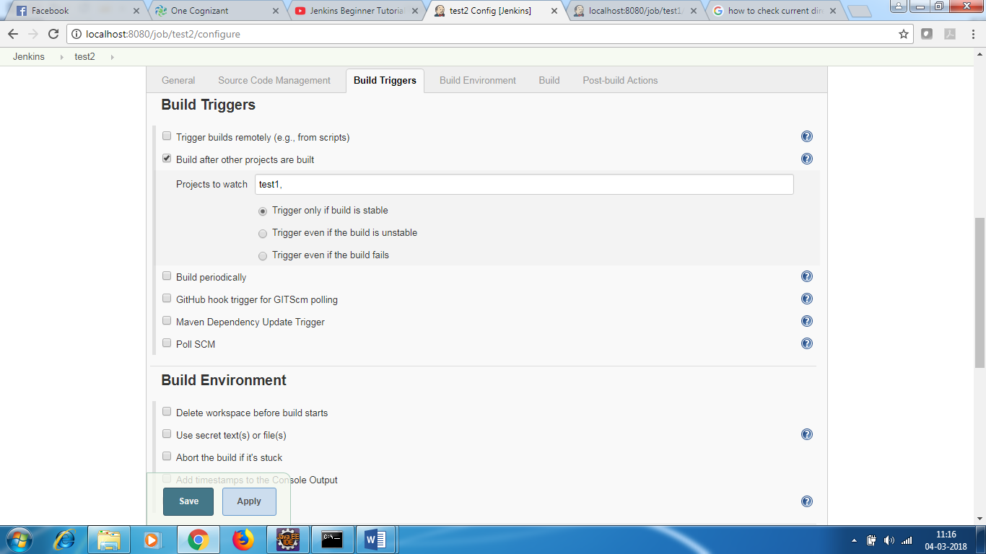

In post build actions :

Select projects to build – test3

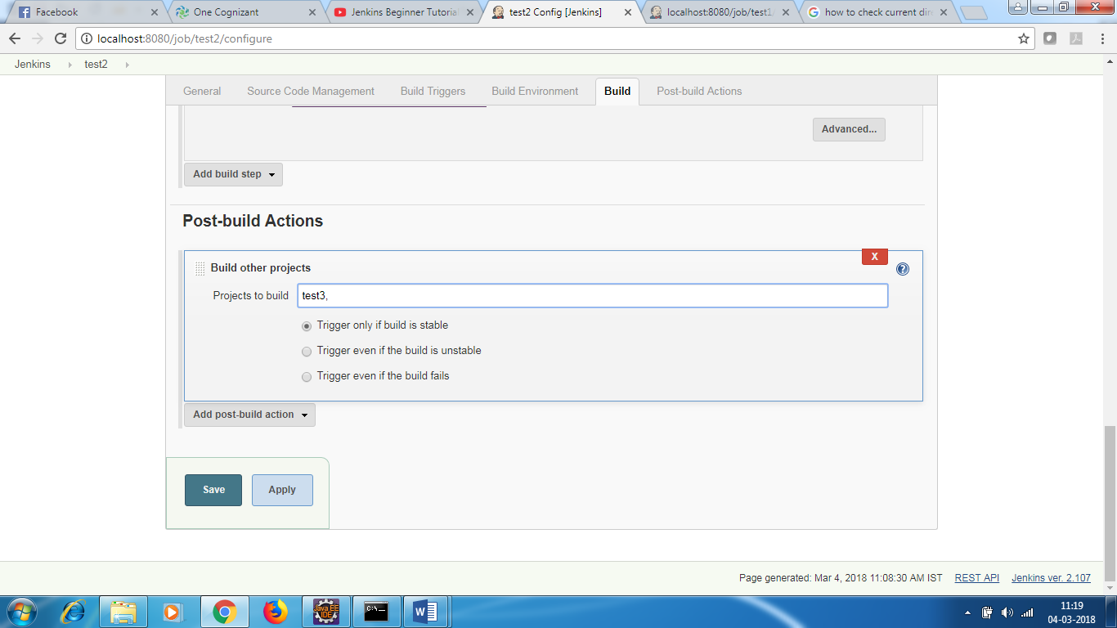

Now test1 , test2 and test3 are chained .

When you run test1 ,after that test2 and test3 are automatically run

When you run test1 , you see test 2 is in queue.

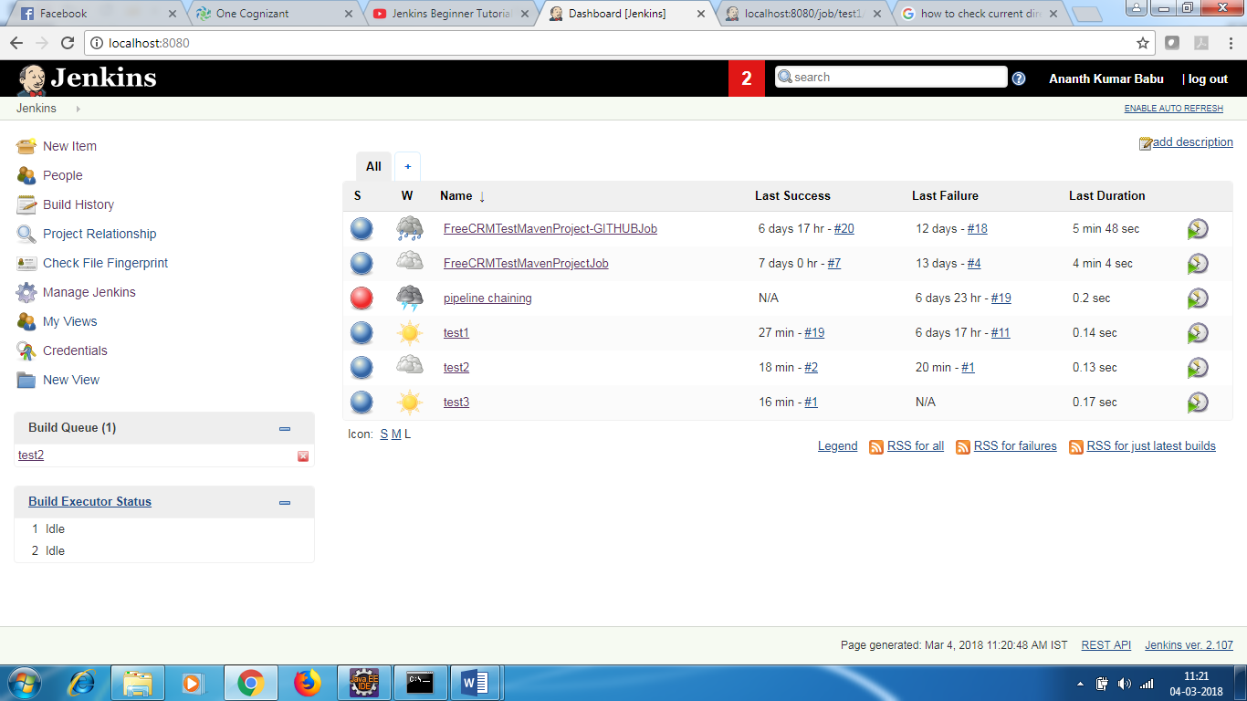

After sometime , you see all test1 , test2 and test 3 is run.

Jenkins integration with GIT – how to run the build when there is change in script

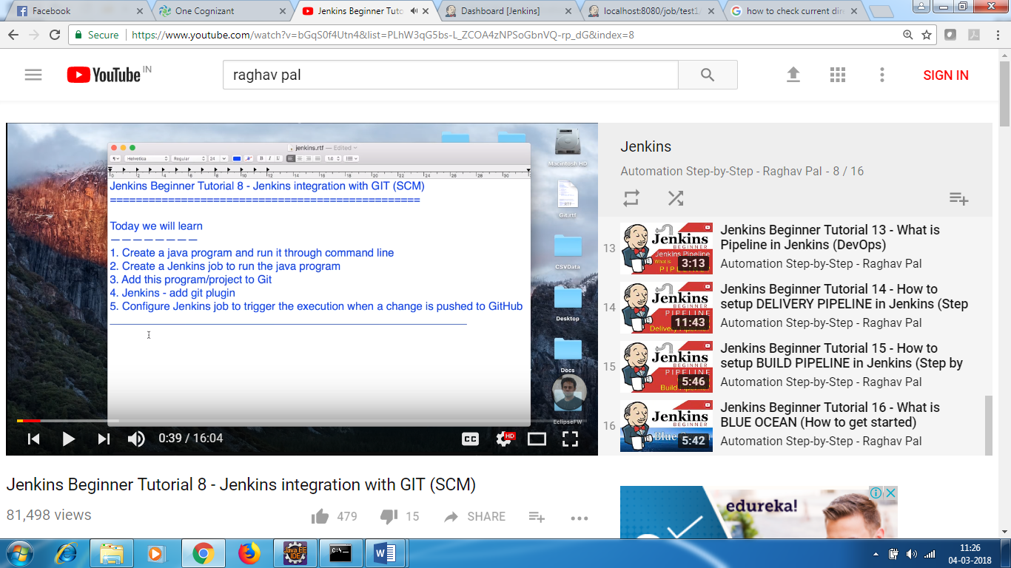

* Create a Hello.java project
* Go to cmd – enter the package path and compile

C:\Users\Hp\workspace\Selenium Project\Raghav_Java_Jenkins_SCM\src

Javac Hello.java

Now run it

Java Hello

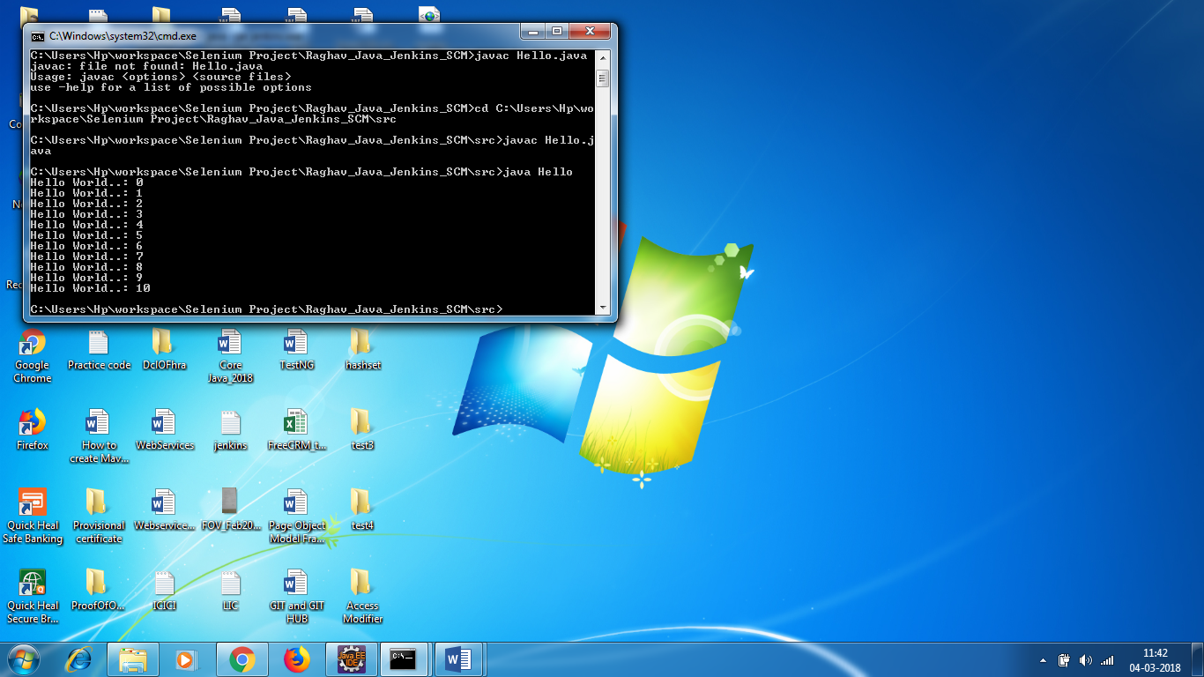

If you want to start Jenkins in other port

Java –jar Jenkins.war httpPort=9191

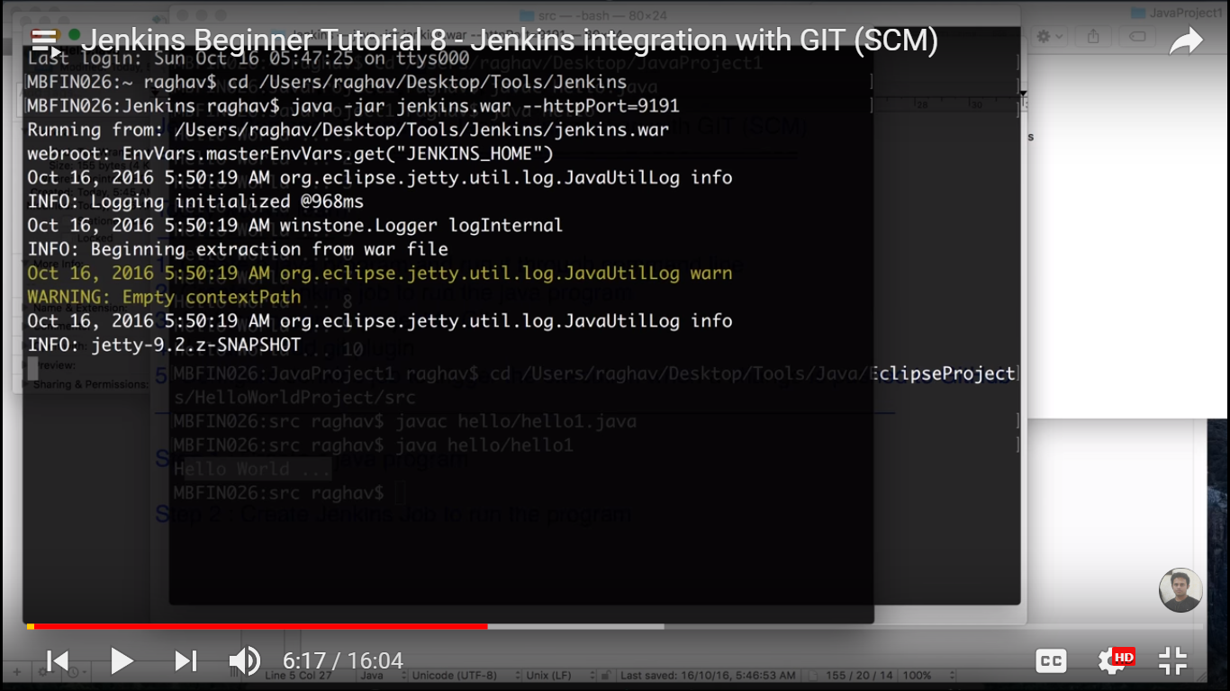

* Create a Jenkins Job – FreeStyle – Hello world
* In window batch command

cd C:\Users\Hp\workspace\Selenium Project\Raghav_Java_Jenkins_SCM\src

javac Hello.Java

java Hello

* Run the build
* 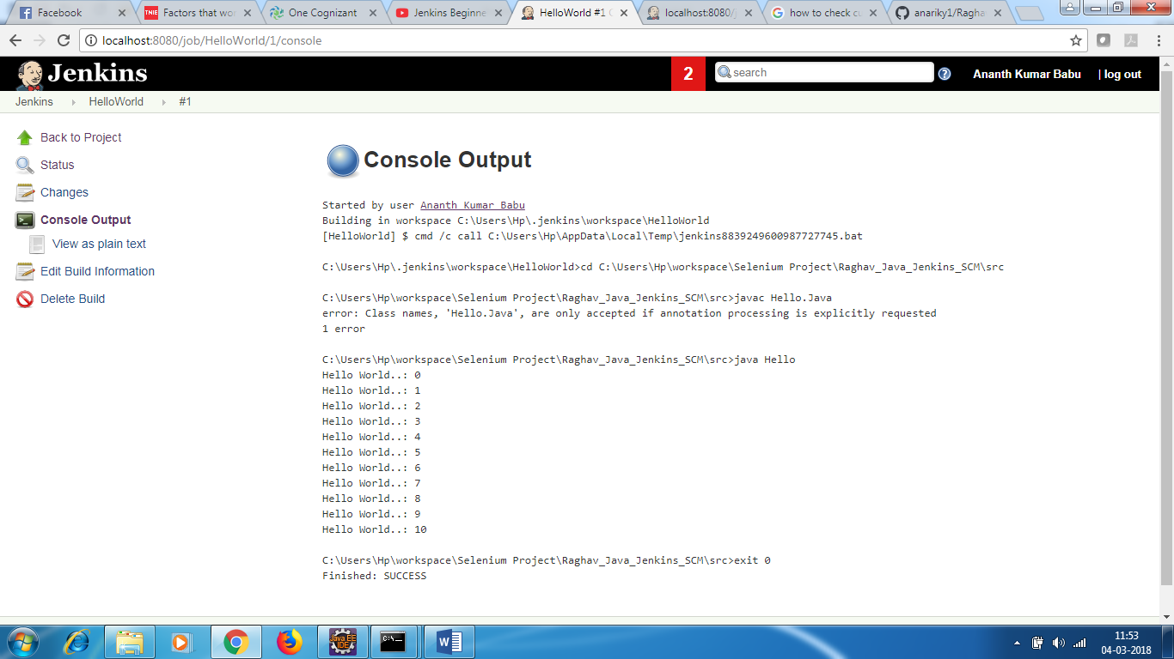

**[*cd** F:\Selenium\SampleTestNG

java -cp F:\Selenium\SampleTestNG\lib\*;F:\Selenium\SampleTestNG\bin org.testng.TestNG testng.xml

cd C:\Users\Hp\workspace\Selenium Project\FreeCRMTest

java -cp C:\Users\Hp\workspace\Selenium Project\FreeCRMTest\src\main\resources\*; C:\Users\Hp\workspace\Selenium Project\FreeCRMTest\bin org.testng.TestNG testng-sanity.xml

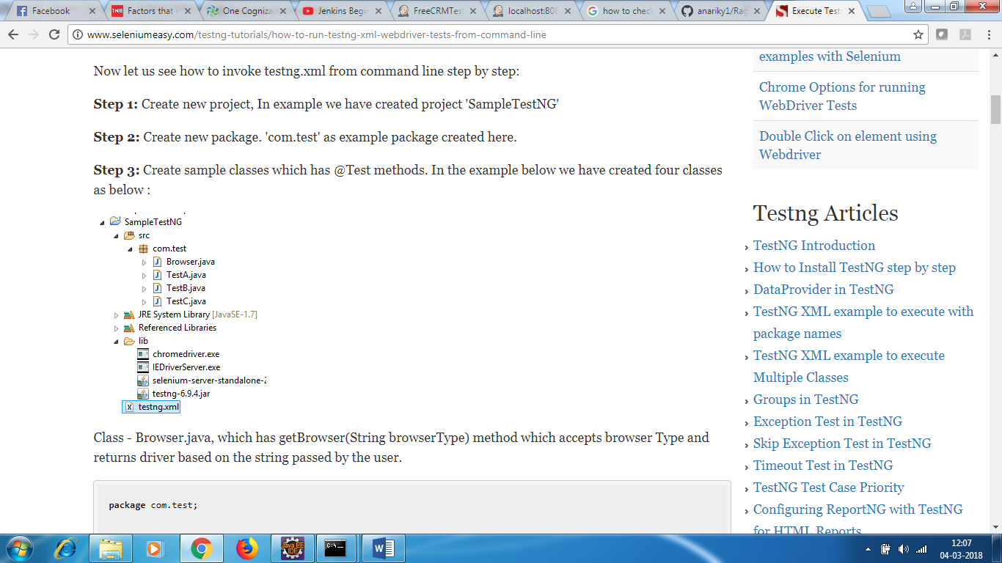

*]

How to run the prog through GIT

* Add this project to GIT
* Give the path of git in Jenkins
* In build triggers – select poll SCM – at what intervals you want to trigger – this will check if there is any change in the build and then trigger the build
* In windows batch –

cd C:\Users\Hp\workspace\Selenium Project\Raghav_Java_Jenkins_SCM\src

javac Hello.Java

java Hello

Run the script

Make come changes in the script and push the changes , it will run automatically.

